Sample assessment task

Mathematics Essential – General Year 12

Task 5 – Unit 3

Assessment type: Statistical investigation process
This statistical investigation is in two parts:
Part A is done as class work and leads the student through the collection and analysis of a random sample of students’ data from the CensusAtSchool website.
Part B is an extension of the statistical investigation in Part A. Students will need to have access to technology with a spreadsheet function.
Feedback for Part A is not intended to be used to award marks for assessment. It is recommended to have class discussion and a review of Part A before administering Part B.

Conditions:

Period allowed for completion of the task:

Part A: one week in class

Part B: 50 minutes in class under test conditions, technology and/or calculator permitted

Maximum number of marks: 26 marks
Part A: 3 marks
Part B: 23 marks

Task weighting:

7% of the school mark for this pair of units
_________________________________________________________________________________
Can arm span be used as a predictor for height?
Archaeologists and forensic experts often unearth skeletons which are not complete. The proposition is that there is a strong enough association between the height and arm span of a person and therefore you can predict the height of a skeleton using the arm span.
Part A: Data collection
CensusAtSchool was a nationwide project that collected real data from students by way of an online questionnaire. It provided a snapshot of the characteristics, attitudes and opinions of those students who completed questionnaires from 2006 to 2014. It can be located online: http://www.abs.gov.au/websitedbs/CaSHome.nsf/Home/Home.
While the data base is very large, you can sample the results of the survey to allow you to answer statistical questions such as ‘Can arm span be used as a predictor for height?’

Task 1
1. Go to CensusAtSchool using the link above.
2. Choose Random Sampler from the Explore Data & Stats menu and click on Accept for the conditions of use.
- Follow the instructions to create and generate a random data sample:
  - Reference year: Select 2014
  - Questions to display: Select data by question: Choose Question 9 and 11
  - Sample Size: 30
  - Sample characteristics: Select by state/territory: All states/territories
Select year levels: All year levels
Select sex: All
e) Click on Get Data Sample
- Download and save the data xls sample file.
- Some data may be significantly different from the rest. These are outliers and are probably due to an error in measurement or recording. Remove any pairs of measurements you consider are outliers.
- Draw a scatterplot for the remaining data with height as the horizontal axis and arm span as the vertical axis.
- Describe the association between the two variables i.e. Height and Arm Span.
- Print the scatterplot and draw a trend line by eye.
- Show how the trend line can be used to predict the height of a student who has an arm span of 150cm.

Task 2
- Repeat the above process with a different random sample.
- Were the predictions the same for each sample? Comment on why/why not the predictions were the same.

Task 3: Using a prepared sample
The following random sample was extracted from CensusAtSchool. The data is from students who were in Years 10, 11 and 12 in 2014.
Use a spreadsheet to draw a scatterplot for the data.
Height | Arm span
153 | 124
175 | 180
180 | 180
165 | 161
175 | 163
185 | 185
184 | 190
168 | 150
182 | 180
150 | 147
167 | 64
187 | 174
175 | 170
178 | 175
180 | 161
162 | 159
172 | 164
164 | 169
164 | 152
168 | 160
181 | 186
190 | 163
184 | 184
171 | 174
161 | 160
175 | 180
171 | 164
173 | 175
150 | 150
153 | 124

Feedback on Part A
Task 1
1–5. Sample of data generated from CensusAtSchool, with four outliers removed.
Height | Arm span | Height | Arm span | Height | Arm span
156 | 155 | 159 | 57 | 127 | 129
168 | 63 | 169 | 160 | 161 | 167
150 | 23 | 183 | 80 | 160 | 150
135 | 134 | 171 | 171 | 153 | 149
171 | 175 | 167 | 159 | 178 | 20
158 | 163 | 162 | 151 | 144 | 140
155 | 155 | 160 | 165 | 166 | 166
145 | 149 | 140 | 123 | 178 | 180
161 | 156 | 169 | 168 | 158 | 169
157 | 150 | 143 | 140 | 165 | 134

6–8. Scatterplot with trendline by eye.
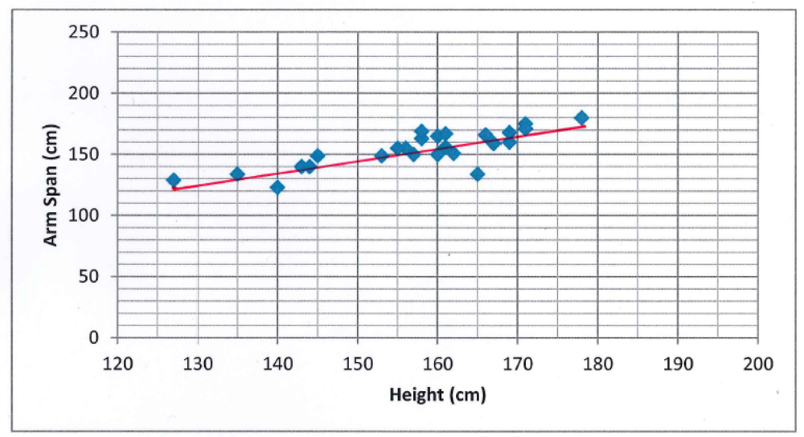
There is a strong, positive, linear association between height and arm span.
9. Prediction from trend line
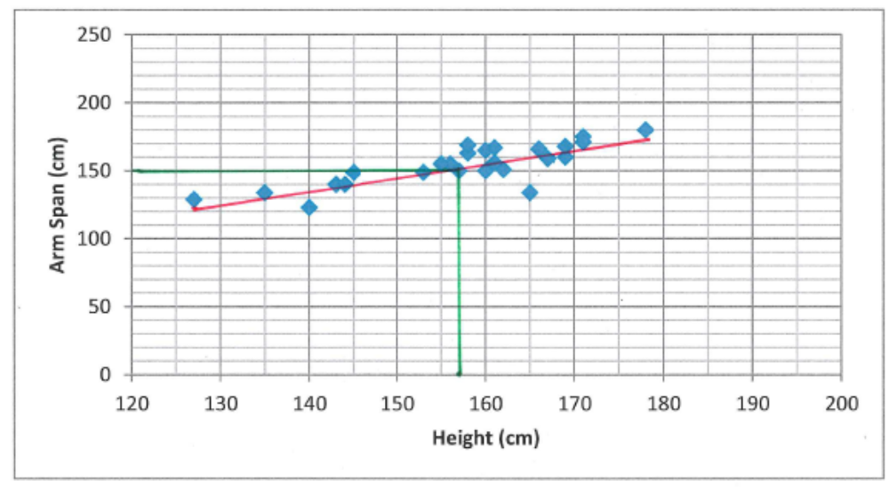
Based on the trend line, a student with an arm span of 150 cm would have a height of 157 cm.
Task 2
1. Sample 2 of data generated from CensusAtSchool, with two outliers removed.
Height | Arm span | Height | Arm span | Height | Arm span
72 | 81 | 155 | 156 | 174 | 174
164 | 167 | 168 | 167 | 154 | 153
161 | 175 | 155 | 153 | 136 | 134
155 | 156 | 153 | 147 | 175 | 160
167 | 105 | 160 | 157 | 168 | 168
159 | 164 | 146 | 152 | 138 | 125
169 | 182 | 155 | 161 | 168 | 167
183 | 183 | 149 | 145 | 175 | 122
150 | 151 | 163 | 164 | 160 | 160
183 | 184 | 165 | 159 | 166 | 66

Sample 2
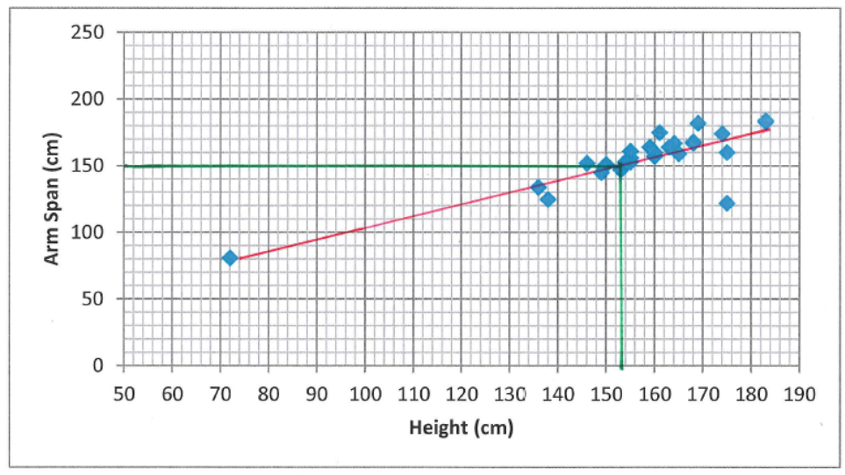
There is a strong, positive, linear association between arm span and height.
Based on the trend line for sample 2, a student with an arm span of 150 cm would have a height of 153 cm.
- Comments on predictions
In the first sample, the predicted height for a student with an arm span of 150 cm was 157 cm. In the second sample, the predicted height was 153 cm. The predictions differ by only 4 cm so, for someone of school age, arm span seems to be a good predictor for height.
Task 3
Scatterplot for prepared sample

Marking Rubric for Part A
Specific behaviours | Marks
Completes Part A to a highly satisfactory level  Completes Part A to a satisfactory level  Partially completes Part A | 3  2  1

Part B: Which, if any, is the better predictor for height – arm span or the length of a person’s right foot?

A completed statistical investigation should include:
- an introduction that outlines the question to be answered and any further questions that could be explored
- selection and application of suitable mathematical and graphical techniques you have studied to analyse the provided data
- interpretation of your results, relating your answer to the original problem
- communication of your results and conclusions in a concise, systematic manner.

Your investigation report should include the following: (23 marks)
1. Introduction – two or three sentences providing an overview of your investigation (3 marks)
2. Numerical and graphical analysis
- choose various statistical measures you have studied to analyse the data (4 marks)
- consider the most appropriate graphs which represent the data provided (5 marks)
3. Interpretation of the results of this analysis in relation to the original question (7 marks)
- describe any trend and pattern in your data (two to three sentences)
- state how your data relates to the original problem (two to three sentences)
- use your knowledge and understanding gained in this unit to explain your results in one paragraph
4. Conclusion (4 marks)
- summarise your findings and conclusions in one paragraph.

DATA
A sample of data from the 2014 CensusAtSchool survey is provided below. The data includes the height, arm span and length of right foot for a random sample of 30 students.
Height | Arm span | Right foot length | Height | Arm span | Right foot length | Height | Arm span | Right foot length
170 | 71 | 23 | 158 | 150 | 30 | 162 | 130 | 25
155 | 150 | 21 | 169 | 174 | 28 | 147 | 27 | 24
169 | 173 | 26 | 55 | 55 | 23 | 176 | 176 | 26
177 | 176 | 23 | 165 | 160 | 36 | 148 | 149 | 23
153 | 149 | 26 | 147 | 142 | 21 | 156 | 155 | 24
150 | 166 | 25 | 175 | 176 | 25 | 172 | 178 | 25
159 | 156 | 26 | 166 | 157 | 26 | 150 | 142 | 24
170 | 162 | 26 | 150 | 136 | 21 | 158 | 80 | 25
169 | 154 | 26 | 176 | 171 | 24 | 145 | 147 | 21
162 | 152 | 26 | 163 | 164 | 23 | 167 | 169 | 21

ACKNOWLEDGEMENTS

First paragraph under ‘Part A: Data collection’ adapted from: Australian Bureau of Statistics. (2014). CensusAtSchool. Retrieved March, 2015 from www.abs.gov.au/censusatschool
Used under Creative Commons Attribution 2.5 Australia licence.

Data in Task 3, Feedback on Part A (Tasks 1 & 2), and Part B from CensusAtSchool, Australian Bureau of Statistics.
Used under Creative Commons Attribution 2.5 Australia licence.

Marking key for sample assessment Task 5 – Unit 3
Introduction
I have been asked to decide which, if any, is the better predictor of a person’s height; his/her arm span or the length of his/her right foot. In order to make an informed decision, I will compare the strength of the association between the pairs of variables; that is, the association between height and arm span and the association between height and the length of the right foot.
Specific behaviours | Marks
Provides a simple introduction of the question | 1
Restates question in his/her own words | 1
Mentions comparison of association between variables | 1
Total | /3

Numerical analysis
Of the data, there are four outliers
Height Arm span Right foot
170 70 23
55 55 23
147 27 24
158 80 25
These have been removed for the graphical analysis
Specific behaviours | Marks
Identifies one outlier | 1
Identifies at least two outliers | 1
Identifies all outliers | 1
Removes outliers | 1
Total | /4

Graphical analysis
Specific behaviours | Marks
Constructs a single scatterplot | 1
Shows comparative scatterplots | 1
Uses a similar scale for the horizontal axis (height) | 1
Presents correct graphs, including labelling | 2
Total | /5

Interpretation
Discussion of sample interpretation:
Outliers have been removed from four data points as these were probably due to incorrect measurement and would therefore have not given a true picture of any association between the variables.
The scatterplot for height and arm span is positive and linear. The association appears to be strong.
The scatterplot for height and right foot length is not linear. The association appears to be weak.
Specific behaviours | Marks
Interpretation linked to numerical and graphical data | 1
Makes an appropriate statement about the outliers | 1
Gives a reason for removing the outliers | 1
Compares the shape of each scatterplot | 2
States the linear relationship between height and arm span | 1
States the non-linear relationship between height and length of right foot | 1
Total | /7

Conclusion
Short statement outlining summary of findings
Sample conclusion:
The removal of four outliers from the data has reduced the sample to 26 students.
Analysis of data from these 26 students has shown that the linear relationship between height and arm span is a better predictor of height as there is a strong association between the two variables.
Specific behaviours | Marks
Makes a valid statement about the results | 1
Relates conclusion back to the original question | 1
Refers to strong relationship/association between height and arm span | 1
Provides a concise and coherent summary of the analysis | 1
Total | /4

